BARNES PRIMARY EARLY YEARS SELF EVALUATION – 2019

Quality of education
Intent - Outstanding
Our aim: for all of our learners to be safe, happy, determined, empowered, kind, articulate, co-ordinated and strong risk takers.
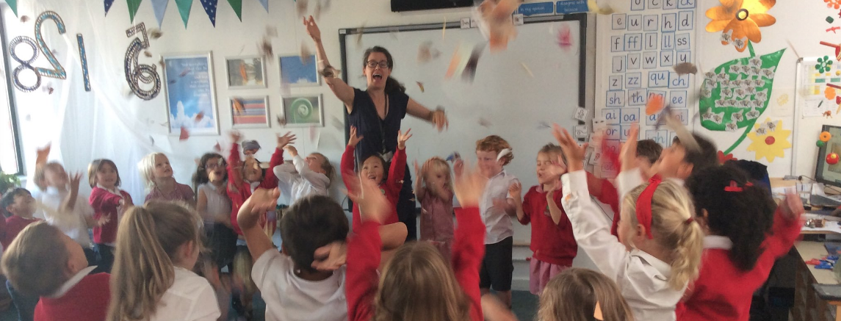

We have designed every aspect of our curriculum with these aims in mind to create a happy, productive learning environment – from the warm welcome on the door, the calm routines, the fascinating visitors to the inspiring provocations set up for free-flow learning. Our curriculum involves half termly themes that have been refined over many years in response to Continuous Professional Development and reflection; continually improving enabling environments; and most importantly, highly skilled, enthusiastic staff who see every moment as a learning opportunity.

We understand our crucial role as the building block for the rest of the school, both in terms of the child’s learning and development, and in the relationship we build with their families. We work tirelessly to build trust and positive attitudes to learning, knowing that our work as the first welcoming step into the school as a whole is pivotal to a child’s success.

We carefully structure our day to balance short adult-led learning, with longer child-led sessions. We expect both approaches to foster the characteristics of effective learning and produce deep level learning. We have clear progression in the skills needed across the Prime (Physical Development; Personal, Social and Emotional Development; Communication and Language) and Core areas (Mathematics, Literacy, Expressive Arts and Design and Understanding the World). We plan a wide variety of experiences (both in and out of school) to enable children’s development in coherent sequences. For example, our ‘writing’ lessons utilise fun gross motor and fine motor exercises, developing into ‘I love drawing’ sessions to cultivate prewriting shapes before we even start on letter formation. We also changed the way we did our Reception Nativity, to ensure that minimal child-led learning time was lost to rehearsals and the experience was a thoroughly enjoyable one for all children involved. By putting the child at the centre, we were able to produce a high quality product, with fabulous singing, speaking and participation from all children, whilst maintaining the children’s well-being at the end of a long Autumn term.

Children in Reception benefit from specialist music and Physical Education lessons once a week, in addition to a teacher led PE lesson, and the input of a specialist art teacher in specific projects. We effectively utilise other parts of the school such as the pond and sports halls to enrich our children’s learning experiences. Children also have a focused computing lesson from the computing lead of the school once a week, which either uses iPads or the computing suite.

Our longstanding partnership with parents enables us to offer enriching experiences. Parents help us with cooking, reading, checking the Book Packs (see below in phonics teaching), talking to children in different languages, explaining their jobs and helping us take children on relevant trips.

We believe in meticulous planning to utilise all opportunities, yet we also practise ‘planning in the moment’ where knowledgeable staff draw on their training to extend learning, and intervene effectively to support the child’s next steps at that point of learning. We adjust our planning in response to our observations, be it minor tweaks or sometimes radical changes based on the needs of the cohort. For example, analysis of our reading attainment, in Nursery two years ago, showed us that we needed to completely reorder our themes. We moved our ‘Fairy tales’ theme to earlier in the school year to provoke story telling amongst our children. This has proved very effective. We have since added more story scribing, dramatic story telling and music and movement into our practise which continues to build on our already strong outcomes.

We understand what research tells us; that reading, writing and maths must be purposeful and connected to real-life situations for young children to learn. Revisiting and repetition are crucial for long-term memory. We believe that to enhance our literacy and maths skills, our Prime areas must be well taught and fostered. As such we plan for exquisitely beautiful continuous provision and exceptionally engaging adult-led sessions. Developing a love of reading and the ability to communicate clearly is at the heart of all we do. We share this passion and enthusiasm with our parents in our curriculum evenings and regular communications.

Where we believe intervention is necessary to support children to make essential gains in their learning, we utilise time where they do not miss out on other curriculum areas (such as when the class is taking turns to wash hands before lunch), or we go to them in their play and skilfully support them in the moment, based on their agenda. The main exception is the Listening and Attention groups carried out in a quiet room away from the main Nursery environment.

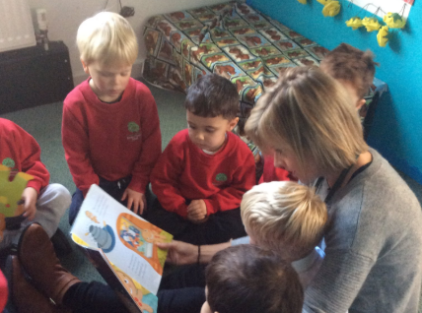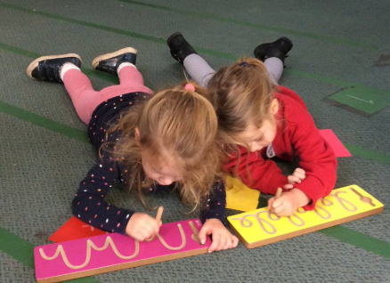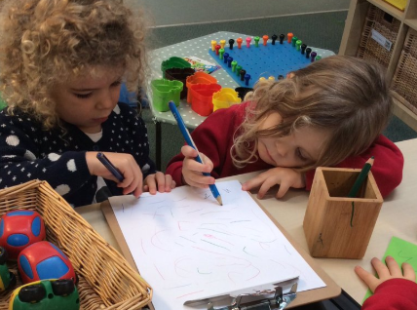

Actions to sustain excellence in our intent (September 2019)
- Members of the team to be released to prepare CPD sessions and amend medium-term plans in response to their recent training on music and movement
- Curriculum maps and theme (knowledge) maps to be updated with developments
- To adjust our enabling environments and positive relationships in line with our Action Plan created following the review of all curriculum areas in Summer 2019

Implementation - Outstanding
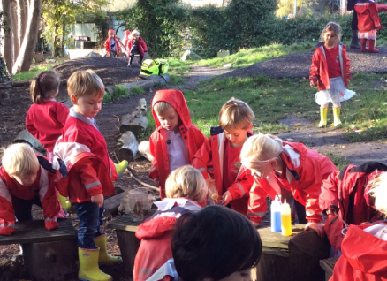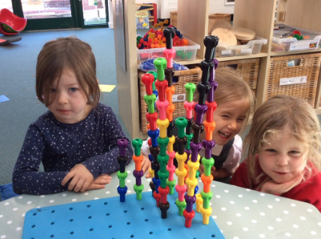
All the team have excellent knowledge of child development and the progression in the curriculum we teach, due to the bespoke CPD provided for the EYFS team. Leaders ensure there are constant feedback and reflection opportunities in day-to-day practise, whilst providing cutting-edge training sessions for all the team outside of contact time, to ensure consistency of provision across the EYFS. We always attend the annual EYFS conference organised by Achieving for Children. We find this an invaluable time to view, refine and reflect.

Excellence is also maintained when colleagues go through the Schools Direct training programme with us. This proved highly successful with one of our current outstanding Reception teachers and we are looking forward to another opportunity to do so next year with a new Schools Direct student.

Flipcharts, visual prompts and manipulatives clearly support the learning intentions, whilst ‘talk for learning’ is used effectively to promote discussion and enable teachers to check learners’ understanding. This is always supported by excellent modelling, intentional vocabulary extension and the use of sentence starters, which are rehearsed, to ensure children communicate in whole sentences. Staff adapt teaching when necessary and skilfully respond to children’s contributions and individual needs.
The environment, adult lesson structures and methods are designed to embed concepts long term for children. For Early Years, this may be the repetitive practice of putting on our own coats, or remembering what an arrangement of three can look like and how many different ways it can be rearranged. Practitioners use any available opportunity, such as counting fruit for snack, or blending words whilst waiting a few minutes to go into the lunch hall.

We assess children constantly, in our daily observations and team discussions so that we know our next steps. Each half term we assess our children against the 7 areas of Development Matters and record these in marksheets in order to make plans for intervention, make adjustments to the environment and our teaching practice. All of these judgements are moderated by the whole team (Leaders of Learning, Learning Support Assistants and teachers) to ensure accuracy and a holistic picture of each child. This is not a burden but an enlightening exercise to see the big picture of a cohort and allow reflection.
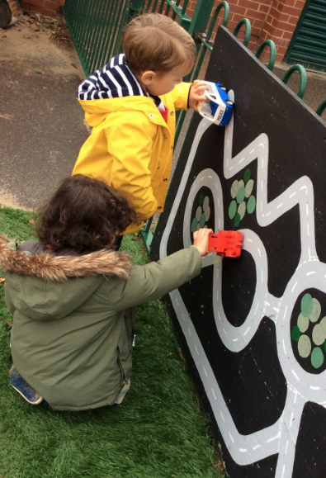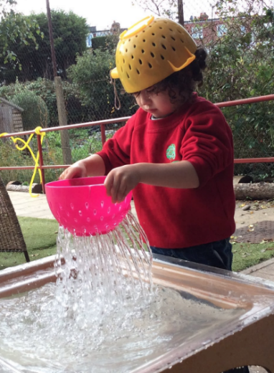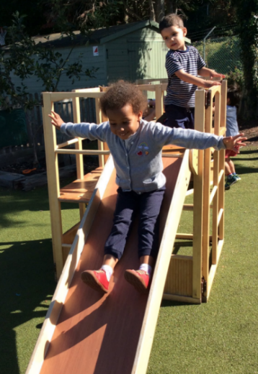

A calm, yet high energy atmosphere is created in Barnes, where high levels of engagement and sustained concentration are seen throughout. We select excellent resources, whilst minimising set up, so that staff are released to pour their energies into high quality interactions during the day. Resources are linked logically to the learning intentions or skills progressions currently underway, whilst also providing open ended scenarios so that children can follow their own imagination or lines of enquiry, and be challenged or supported at any moment.

We welcome many visitors each year to our school to look at our learning environment (both physically and in terms of teaching culture). This has included providing an annual Forest School Session experience for a local Reception class and working in partnership with local schools to improve their provision.

Judging by the level of engagement and the positive feedback we receive annually in our parent questionnaire, we have a strong partnership with our parent body. The information we give out weekly in our updates, the additional support leaflets (for example on pencil grip or maths) sent home, the ‘how to help videos’ and the evening workshops we offer, have impacted very positively not only our relationships with parents, but importantly, the progress of our children.

Recent Parent Feedback 2019
We are a listening organisation and the teachers are accessible at drop off and pick up every day. We also organise Learning Love and Laughter parental observations where parents can observe their child for an hour in Reception or Nursery. This strengthens our partnership and also provides yet another opportunity for dialogue with our parents.

Please see appendix for the parent questionnaire response in 2019.

The feedback below came from parents this year in 2019.

I was profoundly touched by Reception's nativity performance. While you're already working with some great raw material - those kids are darned cute - it takes immense vision, passion, talent and a whole lot of hard labour to put on the show we saw. … we are so fortunate to be able to see our children through your eyes. You recognise their potential and strengths, and they followed through in the most beautiful way with their singing, acting, humour and discipline. …. You and your colleagues inspire her, and that's all I can hope for. As a conclusion to first term at Barnes, the performance was an astounding demonstration of what the school can do and has set a very high bar in our minds and hearts. Thank you to you, Miss Kaler, Natalie and all of the teachers for your tireless dedication.

Myself and my husband… didn't get a chance to chat to you at the curriculum evening but we just wanted to say the HUGEST thank you to you both and all the teaching assistants in reception. We are completely blown away by Barnes Primary and can't thank you enough for the energy you put in to making learning such a fun and happy experience for them. We feel so incredibly lucky.

Love of reading

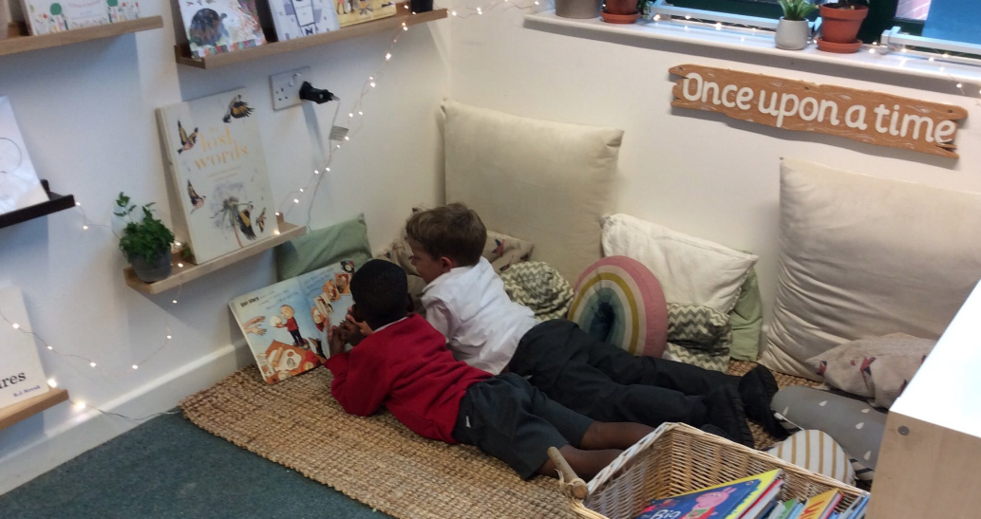

Our phonics teaching is logical and rigorous, following the Letters and Sounds progression (whilst utilising Jolly Phonics and Read Write Inc where we find useful). It is only a small part of our approach to nurturing a love of reading. These include:
- Daily adult-led phonics teaching
- High quality texts in all areas of the Learning Environment (inside and out)
- High quality story book packs for YN children to take home weekly, with props and prompts as guidance for parents
- A wide selection of levelled reading books for YR children to take home which match their phonic knowledge and a library book for parents to read to them. Children select 3 books a week.
- Reading Journals which support parents with useful reference material and facilitate home-school partnership due to space for messages, which are checked daily
- Systematic learning of High Frequency Words (YR) in playful ways to promote reading fluency and a video created for parents to give examples of playful ways to support at home
- A range of texts read daily by the class teacher and Leader of Learning across the EYFS, modelling reading strategies, reading for fun and critical thinking
- Music and movement utilised to enhance the wonder of story
- Dramatic story telling with the children
- Story scribing children’s stories
- Guided Reading Sessions for each child once a week in YR
- Author packs that are changed regularly
- Key words in the environment (on the radiator, word mats or written on the ground)
- Sharing of favourite books that children have brought in themselves
- Trained parent readers listening to each child read weekly in YR
- Weekly parent readers in Nursery to raise the profile of story during free-flow time
- Encouraging birthday books rather than sweets
- Making of class books and individual story books

Actions to sustain excellence in our implementation (September 2019)
- To continue the development of Maths Reading Packs for Nursery – 15 more
- To maintain the high quality of teaching interactions by reviewing pedagogy with the whole team weekly

Impact - Outstanding

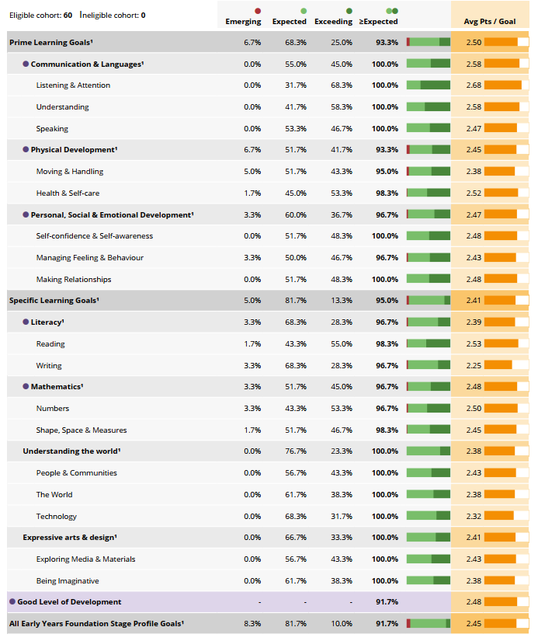

Year | Measure | Barnes | National | Richmond | Kingston
2019 | Good Level of Development (GLD) | 92% | 71.8% | 80.6% | 75.9%
2018 | GLD | 83% | 71.5% | 80.5% | 76.8%
2017 | GLD | 78% | 71% | 78% | 76%
3 year average | GLD | 84.2%

Children consistently attain significantly above the national average at the end of the EYFS. The principle evidence for this judgement is the consistently high attainment. By the end of EYFS attainment and achievement compare very favourably with schools, both locally and nationally. The Early Years Foundation Stage team are to be commended for the significant rise (9%) in the number of pupils achieving a Good Level of Development (GLD). This is due to better provision enabling pupils to make faster progress in writing. In 2019 92% of children attained a GLD. In 2019 the school’s early years’ assessments were moderated by an external local authority team. All assessments were judged to be accurate and the quality of practice received some very favourable comments.

Year 1 teachers have observed in recent years how strong children come into Year 1 ready for the KS1 curriculum. Transition arrangements are strong for children, parents and staff. These procedures are embedded and improved each year.

Amongst all this, we take great pride in connecting with the wider school through theme weeks such as Arts week, DT week and World book day, always keeping sight of our role as ‘foundation stage’ and the importance of a wide curriculum.

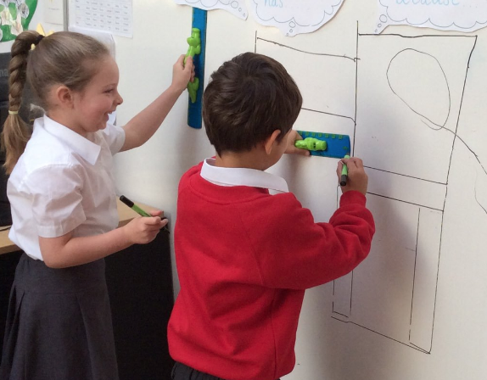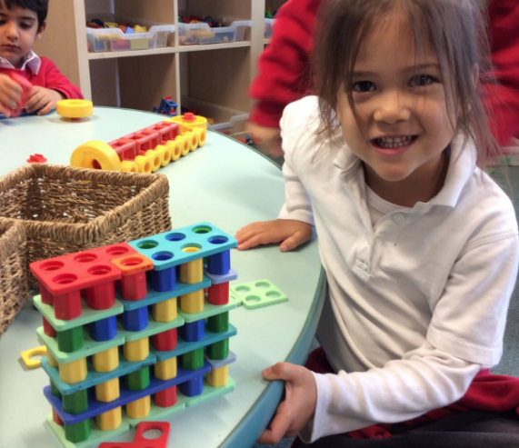

Actions to sustain excellence in our impact (September 2019)
- To learn to use the new features of ‘Evidence Me’ (electronic observation system) to further our ability to assess and reflect
- To become adept at utilising our new SIMS marksheets (to the standard we were able to interrogate our old excel trackers), to help us meet the needs of all pupils
- To embed working developments and engagement of parents to ensure GLD remains about 90%

Behaviour and Attitudes - Outstanding
We have high expectations of all our children. Transitions are smooth and calm. In whole class learning children are not easily distracted, maintain focus on their activity for a period of time, think of ideas and notice patterns in their experience. In free flow-learning, children bounce back after difficulties, seek challenges and take risks. Staff from across the school comment on the children’s consistently good behaviour and positive learning attitudes. The children are happy, excited and motivated by their experiences. They are well behaved, play cooperatively and develop their independence during their time at Barnes. Attendance is high. For the first time in 2018-19, a family activated their right for their child to be part time in Reception. This impacted on our attendance percentages.
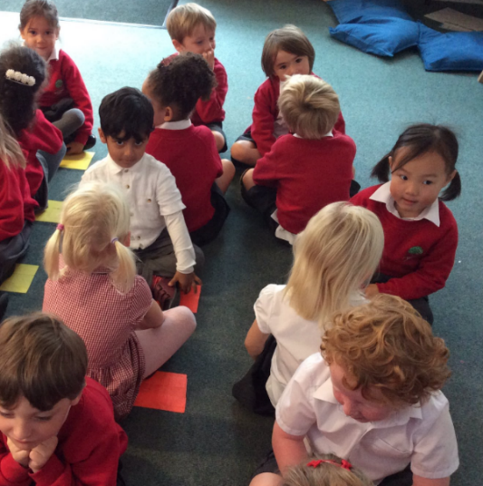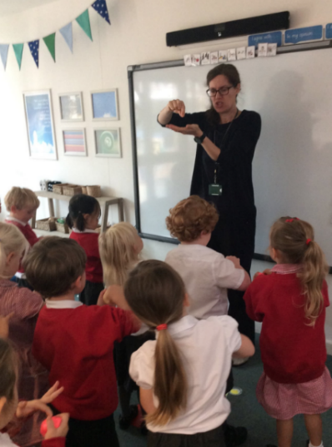

Behaviour management is consistent across the team, with nurturing, positive relationships among learners and staff being the bedrock of the positive and respectful culture. Leaders, teachers and learners create an environment where bullying, peer-on-peer abuse and discrimination are not tolerated. If they do occur, staff deal with issues quickly and effectively, in age appropriate ways, and do not allow them to spread. We use these as a teaching and learning opportunity, and liaise closely with parents.

Parents often ask us for advice; we share our principles and help problem solve with them. We also share these thoughts in our EYFS newsletters to further support our parents.

Personal development - Outstanding

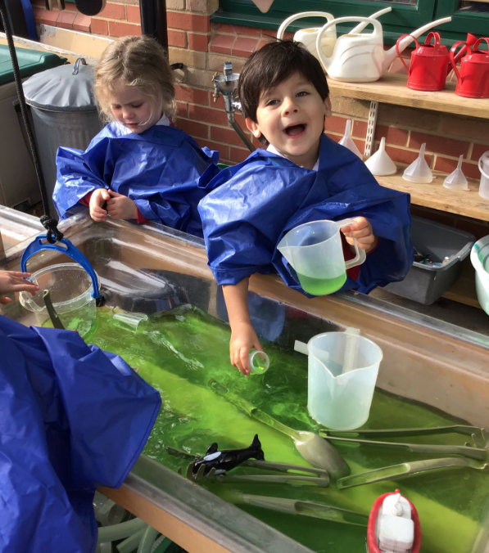
‘Choosing time’ or ‘free-flow’ produces the ‘highest levels of engagement’, or purposeful and happy children. When this happens, we know from research that children’s brains ‘light up’; they make connections and are therefore making progress. These open ended scenarios allow all children to shine. Our curriculum fosters Agency (being able to make choices and decisions to influence events and to have an impact on one’s world); Belonging (being cared for and part of a community) and Competence (the feeling of being successful). Children have space to develop their passions and revisit them as often as they would like. We have the highest expectations for the well-rounded personal development of all children.

98% of children in the EYFS have a freshly prepared school lunch. Nursery eat as a home group in a served family service. This time is used effectively to talk to the children, develop healthy eating habits, and encourage them to eat a wide range of foods. In addition, children build relationships with their peers and adults, as the teaching team accompany them into lunch; it is not a different lunchtime team.
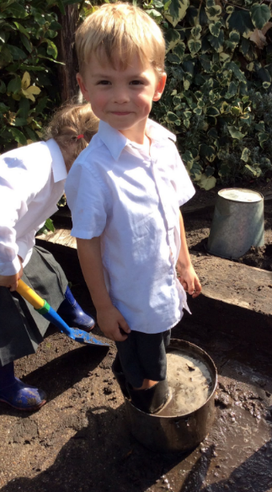
Children are physically active. The learning environment is large and includes an onsite forest school. Our Forest School provides yet another opportunity for holistic learning, often referred to as SPICES (Social, Physical, Intellectual, Communication, Emotional and Spiritual). We are delighted our youngest children are cultivating a love for the outdoors through their Forest School sessions, which is so important for future physical and mental wellbeing, including respect for and care of the environment. There are limited chairs (none in Nursery and only 8 in Reception) within the indoor learning environment. This encourages children to have ‘tummy time’, to squat or kneel at a variety of height surfaces. There are many standing desk surfaces; this not only supports their physical development, but also facilitates their ‘willingness to have a go’ and helps them develop their interpersonal skills, since many more children gather round an activity that interests them, rather than being restricted by the number of chairs. The external areas have been designed to develop core stability and upper body strength. There are places to climb, hang and roll. All reception children have 2 hours of specialised PE a week. 95% of children learn how to cycle at school; 100% of children travel to school using sustainable travel methods, with most walking, scooting or biking. Our children are fit and healthy. We encourage participation in sporting events; Nursery holds its own Sports Day, whilst Reception pupils participate in our annual sports day with Key Stage 1 in the summer term.

We have implemented many Mindfulness and Resilience strategies into our daily routines following recent CPD, to further help our children develop their confidence, independence and maintain mental health. Our school values have been translated into child speak and we refer to them regularly, spotting when children have displayed such characteristics:
- I try new ways of doing things (Creativity)
- I like to explore and learn new things (Curiosity)
- I know others have feelings and I look after them (Empathy)
- I can be strong and say what is true (Integrity)
- I can see opportunities and good in everything (Positivity)
- I’m sure I will be able to do it. It may take time, but it is possible (Self-Belief)
- I keep trying even if it is hard (Resilience)
- I can organise and do things for myself (Responsibility)

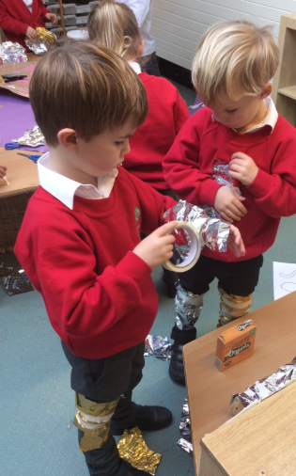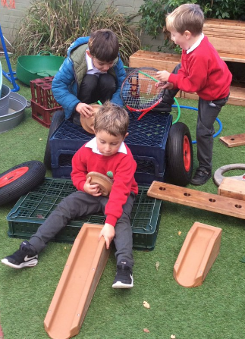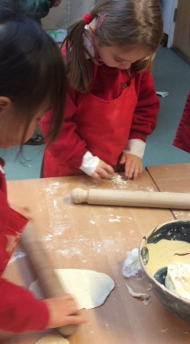
Induction and transition arrangements at the start and end of each year, along with arrangements for transition into Key Stage 1 are exemplary.
- Induction evenings for new Nursery and Reception parents in the summer term before they start
- Home visits by the teaching team
- Stay and play session at the start of term for YN and a taster morning for YR with accompanying coffee morning for parents.
- Staggered start for Nursery; oldest children start first and settle in
- Baseline assessment is carried out in Nursery gradually over the first month
- Reception children are part time for the first two weeks for Reception
- Baseline assessment for 16 children a day in the afternoons of the first week of Reception enable staff to get to know their children very quickly in a calm and happy way.
- Baseline reports sent out at the end of the first week to facilitate home-school discussions
- 20 minute parent consultations for all Reception parents in the second week (before all children go full time in week 3) have ensured we work closely, in partnership, with parents from the outset.
- A whole term of planned events for Reception to get excited and familiar with Year 1
- Reception team part of the welcome and settling in team on the first day of Year 1
- Year 1 follow EYFS based curriculum organisation in first half term
- Year 1 staff attend final consultation with parents to get to know children and parents
- YR parents given hand out as preparation for Y1
- YR parents attend a transition meeting for Y1

Our children quickly learn and follow the routines and expectations of our setting. They are responsible, respectful and know that they are all needed to contribute positively to their school family. They develop their understanding and appreciation of diversity as we proactively give them opportunities to learn about each other and different cultures. We are careful to ensure a real mixture of images, books, and visitors to promote a deep culture of respect in line with British Values.

Actions to sustain excellence in ‘Behaviour and Attitudes’ and ‘Personal Development’ (Sep 2019)
- To invest further in books that promote diversity (for example EYFS level Black History stories and multilingual books) and challenge stereotypes
- Utilise peer observations to share excellent practice and maintain consistency
- To change the timings of Forest School and daily timetable for Reception to free up more child-led learning time, fostering resilience and curiosity
Leadership and Management – Outstanding
A culture of outstanding leadership has been a consistent feature of the Early Years for the last five years. Despite changes of staff, the rigour and continual desire for improvement in our effectiveness has been seamless. The EYFS lead’s view and aim is as follows:
“The current team’s success is because ‘we stand on the shoulders of giants’. Maintaining the high standard we already achieve is possible if we nurture our current strengths, allow time for reflection and work collaboratively as an efficient team. I want to attend to colleagues’ well-being by ensuring they feel protected, trusted and celebrated. When teams feel this ‘Circle of Safety’ (as coined by Simon Sinek), innovation can flow. I want to release team members to creatively grow this EYFS provision, finding ‘less is more’ solutions and continually deepening our understanding of how young children learn.”
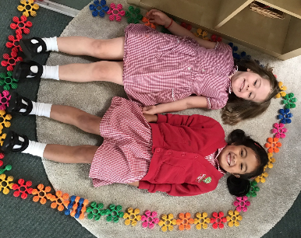
An effective distributed leadership model is well established. As a result, roles, responsibilities and expectations are clear. Shared values, policies and practice are a hallmark of the teaching in Early Years, as evidenced by the constant team teaching, where all members take the lead at various points. There is a specialised EYFS CPD programme which is tailored to meet the needs of all staff. Pedagogical skills are developed through regular observations. The Early Years moderation team (2019) confirmed that assessment judgements were accurate and robust. Leadership skills are honed through teacher involvement in the extensive partnership work that is undertaken with local schools.

Premises are continually improved, in enterprising and aspiring ways. This year, Nursery premises will be expanded to meet the community's needs. The undercover area will be enclosed, thus providing a space for more Nursery places and high quality wrap around provision. The external area will be developed at the same time to increase challenge for children, thus raising the quality of our crucial outdoor area. We know from research how much the prime areas of development are better supported when children have daily access to inspiring outdoor areas.

Both governors and the local authority play an active part in evaluating EYFS provision. For example, each year a governor, the Headteacher, Deputy Headteacher and Key Stage 1 leader jointly conduct a one-day internal EYFS review. These annual internal reviews are a well-established practice: they have been taking place for more than ten years. They inform and guide continual improvement.
EYFS Advisor feedback, 2016: I would like to take the opportunity to reiterate that in my view the journey towards excellence that you as a leadership team and the whole EYFS team have embarked on has been incredible. It is clear that the team have worked hard to become a cohesive unit. The leadership of the EYFS has ensured that all staff share the same vision and understand the purpose of why adaptations are being made. All staff have engaged in varied, ‘EYFS tailored’ professional development, in both general practice and specific areas of responsibility. The impact of these opportunities is noticeable in both the environment and the teaching.

Actions to sustain excellence in Leadership and Management (September 2019)
- The new EYFS lead to regularly seek feedback from all team members on effectiveness and areas for improvement
- The new EYFS lead to continue being mentored through the first year of the role by the exceptionally experienced HT and DHT, and AfC EYFS leader meetings
- Ensuring the provision remains exceptional when a building project starts

Safeguarding
The safety of our children is our utmost priority. We come under the whole school procedures such as annual safeguarding training and overseen by the governor premises committee which annually check our indoor and outdoor learning environments. Specific EYFS points are as follows:
- The security lanyard system is part of the whole school, but we find it particularly useful in EYFS. We welcome involvement and volunteers from our parent body. Those who come in regularly (like parent readers in Reception) are DBS checked. One off visits, such as parents coming in to read in a language other than English, sign in at front of house and wear the clear red lanyard. They are never left alone with children.
- Front of house bring latecomers in. They always do this in a kind and child centred manner.
- Following the whole school audit, needs were identified, and action taken
- Safer places audit and external audit are carried out annually
- The excellent team communication ensures we are always building up a picture of the children in our care
- All staff complete safeguarding training annually. New staff are always inducted into best practice in regards to dealing with the youngest children in our school.
- First Aid: all staff undertake annual ‘Safety First’ and six of our staff team are Paediatric certified first aiders
- Forest School has a full ‘Risk Benefit’ analysis, with procedures in place
- Staff are alert to any arising dangers and act promptly to eradicate; for example, we noticed that the corner of the high fence backing on the brook in the corner of the forest school was incomplete. The site manager immediately fixed this.

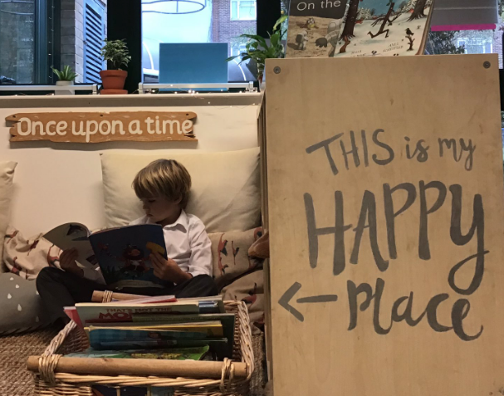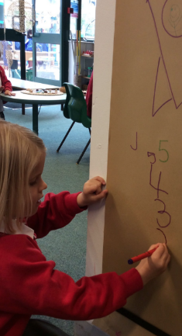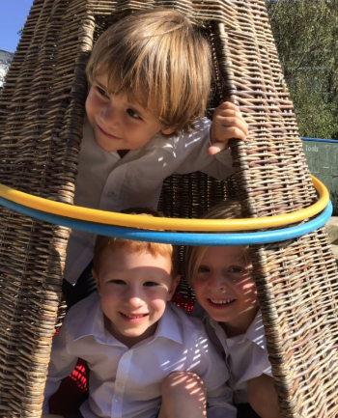

Appendix:
All feedback relating to EYFS in 2019
Class | What I like most about Barnes Primary School. | What improvements have you noticed within the last twelve months?
Reception | The people, the campus, the teachers, everything! | I'm not sure
Reception and Year 2 | Continuous improvement approach and up to date education methodology | A seamless hand-over of the headteacher role
YR Amber | The approach to teaching, the level of expectation/ambition for the children and the loving atmosphere | N/a
Reception Y2 | I love that it is a close community. The teachers are very good in general with what they do. The teaching assistances are amazing. The team is great. I am confident in the current leadership and hope to see a nurturing environment in which my children flourish develop even further.
Amber | Lovely community feel, friendly dedicated staff full of enthusiasm. | We have just completed our first term of reception so I can’t comment.
Reception & Year 2 | The warm & friendly atmosphere | The KS1 playground & the KS1 Hall
Reception | Local. Community feel - all friends live very close. Good teachers in nursery and now reception. Happy child. | N/a
Reception Y2 | Serves the local community Some really excellent teachers | Wider range of after school activities (eg gymnastics)
Reception and 2HM | I like that you have very high standards for everything. Not just the teaching. | Nothing in particular
Reception-Topaz | Warmth-Enthusiasm-Eagerness to help | More dedication
6B / Honeybees Nursery | Academic achievement, high standards of behaviour expected from the children, a positive, encouraging environment for the children. We are so lucky our kids can attend the school! | More sports, better playground facilities, more provision for nursery children (ie full time nurserly availability)
nursery | friendly and forward thinking | n/a
Nursery | It has a very friendly community feel. | N/a
Afternoon | Staff | English Social skills Tries more to do stuff by herself
Reception | Level of care and education with focus on fun | N/a shes just started
Nursery | The positivity of the staff, the enthusiasm and support of the parent community and the children are all very lovely kids! | My son has become much more independent - he is learning how to look after himself in little ways and his communication and listening has improved greatly.
Topaz | There’s a relentless pursuit for success from the teachers who provide rich and diverse learning experiences and have high expectations every minute, every day. Thankyou | Front entrance looks likes it’s been freshened up and is more welcoming. Can’t comment on teaching and learning at such an early stage.
Amber / 2HM | It’s impossible to detail every single thing that makes BPS such an inspiring and nurturing place of learning for my children. My oldest child has only been at BPS for 2 years, but I already see how well he is developing academically and as a person. I would, however, call out the school’s leadership, direction and oversight of a set of positive and clearly defined aims and values. Importantly, BPS also has truly exceptional teachers and support staff who demonstrate and cultivate this spirit and culture throughout the school and in everything they do. I recently attended an event where every teacher at the school spoke and every single one made me feel so fortunate to have them there. The school’s commitment to academic learning is brilliant, but I feel it is the school’s enduring commitment to holistic development and wellbeing that makes it truly stand out and this is my favourite aspect of the school. Whilst, academic results are excellent, it is the importance the school places on developing happy and ‘good’ people. If the above is too long, then... ‘the teachers and support staff (Jo P and Mrs Warner to name only two) are truly inspiring’ | I’m not sure I have anything here necessarily.
3B & reception | My children love school, they never say they don’t want to go to school. They are taught very well but have lots of fun while learning. There is a great balance in the school. Great results but happy healthy children. | Using technology to connect home to the classroom, the girls love it, whether we like or not technology is a part of our life’s and using it to help the kids to do more learning at home is a plus. Rock star tables is a great tool!
Nursery (Bumblebee) | It seems to be nurturing space, welcoming, relaxed but with high standards and great facilities with indoor and outdoor play | We’ve only been with the nursery one term
2HM and Nursery | The genuine commitment from the teachers + the involvement/ community created in collaboration with parents
Reception, year 2 | The school is a nurturing environment with good values. A good balance of strict but fun. Strong focus on
5w - Reception topaz | It's happy and constructive environment- great teachers and staff- providing great extra facilities like after school clubs, fit for sport, music lessons, good food- had great experience with Mrs Huxley, Ms Warner, Mr Griffin, Mrs Beard
Nursery | How great all the staff are | Only been there since Sept
2HM and Nursery | The friendly atmosphere and the dedicated staff who genuinely care about the children’s academic and wider development
Nursery | The quality of the activities and learning at nursery. Every day my son comes home with new songs, ideas, skills. He is clearly highly stimulated and does things that I could never do with him at home | N/a
Reception | Personalised feel. Local, community school. Focus on results | N/a - reception
Topaz | Good communication through apps, keep me informed of learning themes every week. | Can’t comment as only had two months with Barnes.
Nursery | The outdoor play space and how happy my little one comes out everyday | We have only been here a few months
Barnes Nursery | Outdoor space. High quality standard for education
Reception And nursery | The staff commitment, passion and joy.
4b 6b | Ethos - learning love and laughter | More sporting opportunities Ongoing very good mental health support
Amber Class - Reception | The community and how enthusiastic everyone is to make the school a great place for our children. I also enjoy how the teachers include parents so much in my childs education and keeps me informed | We only started in September 2019
Topaz 2D | The high quality of teaching; the community; the innovative teaching ideas; behaviour management strategies; the facilities; core values and morals; school food; excellent parent and teacher communication. | The updated hall in KS1; improvements to the playgrounds; support with internet security;
Reception | Results and feedback. | None yet. Aoife has only been attending for half a term.
Nursery | The facilities that the nursery offer are fantastic for my very active son. The teachers are also very in tune with the children and arent afraid to approach parents when there are concerns | My son has become more settled and I have noticed his maturity levels rise.
Morning | Staff | She has notably improved Her English Her focus too Her social skills Following rules
Amber and 2HM | Its warmth, openness, centre-of-community feel and critically its superb level of teaching | I have not noticed any significant improvements as I haven't seen a need for any!
Nursery; Year 1 | The way the teachers love the children, always going the extra mile | The additional fine motor control; excellent reports
4G and Amber | Warm, caring environment. Strong academic focus. | Improvement in sports provision.
Amber, reception | I like the philosophy that reception is mainly for settling in to school life | Well it’s only been a couple of months but we’ve noticed major improvements in georges reading and writing already
Afternoon nursery | The teachers, classroom layout, set-up and educational setting, excellent ethics and huge creative opportunities for the children.
NURSERY | FACILITIES AND SPACE | N/A
Reception (Amber) Y1M | Sense of community | It has to be a transitional year, but so far nothing negative, still the same high standards
2D Reception - Amber | my happy children! | Teacher-parent communication continues to impress
Reception - Amber | The passion of the staff and the nurturing, caring environment | My child hasn’t been at the school for 12 months yet.
Amber reception | Professional Caring Creative | Early years focus
Nursery | The kindness of the teachers and the amazing communication
Year 6, 3 & Reception | Warm and caring staff. The emphasis on positive competitiveness. Cultural diversity. | Many, related to technology and play equipment
Nursery | Resources available, displays, friendly teachers. | Been a 24 month break for me and love how fit for sport offer brekkie club (and after school club) care for nursery now!
Reception | The duty of care to the children, the support and encouragement from all the staff and the focus on education and making it fun and palatable for the children. Everyone is very welcoming.
Nursery, YR1 | Great community | Better playground apparatus
Nursery | The community The friendliness Feels like a big home/family | Only been there one half term so can’t comment
Amber | The teachers I’ve met are all so friendly and full of enthusiasm. My son is very happy there. | We are quite new to the school (with one child in reception) and haven’t noticed any changes/improvements.
1L AM Nursery | quality and friendly staff | --
Reception, 3s | V well organised; seem to take time to give all pupils encouragement; high standards ; deal with situations rather than laissez faire | Not noticeable
nursery (morning ladybird) | walkable and beautifully set up and inspiring for our little one...he loves it | n/a
Amber Room | The close knit community it creates and their commitment to teaching children to develop a love of learning. | We've been there only a half term.
Nursery | Excellent communication. Super child-focused learning. Super transitional information in to nursery | N/A
Topaz 2D | Excellent teaching and resources
Nursery (all day) and year 2 | Drive and ambition of all the teachers and staff, and leadership team. | Improved parent communication and engagement.
2HM Amber Topaz | Structure, warmth from the teachers and staff, strictness where you show children clear boundaries and the whole school culture. | More engagement with and from parents

