Remote Learning starter pack

Please find enclosed a number of fun resources and learning opportunities for you to enjoy with your children should you wish to do so. It is a series of unrelated pages and is a pack that we encourage you to dip in and out of. Of course, if you are needing to self-isolate as a family, please do follow the most up to date advice from Public Health England.

We like to spot our school values to encourage children in their play. For example:
- You know others have feelings and you look after them! – empathy
- You can be strong and say what is true – integrity
- You keep trying even if it is hard – resilience
- You are sure you will be able to do it; it may take time but it is possible – self belief
- You can see a need and do something helpful – personal responsibility
- You try new ways of doing things – creativity
- You can do things for yourself – self sufficiency

This is a helpful reference point for when you are playing with your child. The phrase in blue are a lovely way to extend learning and create memories together

WATCH, WAIT, WONDER

- Try not speaking until you are spoken to.
- Be a warm & friendly presence. (Give your attention. Smile. Be on their level)
- If you are fascinated, you will be led by the children.

How can I make a difference?
Show they have been understood | with gestures, listening noises, reflecting back, recapping ‘So you think that…’
Suggest | Perhaps you could…What about…Could you try
Encourage | You have thought really hard about where to put this door. I wonder where you will put the windows?
Make links | Have you seen anything like this before?  What do you notice?
Alternative view point | Maybe Goldilocks wasn’t naughty when she ate the porridge
Provide resources | Have you spotted this really great rolling pin?  Get something from the resources room to facilitate their agenda
Explore ideas | Do you think the three bears would have liked Goldilocks to live with them?
Remind | Do you remember what you noticed yesterday about the water tray?
Narrate | e.g. tell a story as you play with the small world  OR Model and think out loud. “I’m turning the cooker on to 180 because that’s what it says in the recipe book.”
Invite elaboration | Tell me more, show me, how did you, what do you think would happen next
Prompt explanations | Why do you think we put that there?
Set challenges | Could you get the water to travel from the tray, to the sandpit without losing any?

We are including our general timetable. You are so welcome to use this as inspiration for your daily rhythm.

9.00-9.10 – Register and morning movement and singing break
9.10-9.30 – Phonics input
9.30-10.00 – Freeflow
10.00-10.10 – Handwriting
10.10-10.25 – Snack and story
10.25-10.45 – Outdoor breaktime
10.45-11.20 – Freeflow
11.20-11.30 – Reset up/tidy
11.30-11.50 – Maths input
11.50-13.00 – lunch and outdoor break
13.00-13.15 – Calming down with relaxing music
13.15-13.35 – Writing input
13.35-14.30 – Freeflow
14.30-14.45 – Tidy up
14.45-15.00 – Leader of Learning session (keywords, story, gross motor, yoga)

Of course if we do Forest School, P.E, Music or cooking the timetable changes accordingly.

Warm ups songs list
(from the Learning Station on youtube)

- If you’re happy and you know it
- Shake your sillies out
- Penguin dance
- Down in the jungle
- Body Boogie
- I’m so happy that’s why I clap my hands
- Heads, shoulders, knees and toes
- Wake up shake up

Please refer to your Spring 2 Knowledge map that we sent out with our Newsletter at the beginning of term. It is also on the website.

Writing ideas
- Writing a postcard to a family member or friend
- Record a diary
- Caption a picture
- Shopping List
- Post-it notes
- Treasure map

Barnes Bears Top Writing Tips
- Finger spaces
- Sounding out words before you write
- Use a word mat and letter formation
- Spelling words phonetically
- Remember it’s ok to make mistakes!

Key Words
Please see below all 100 key words and different ideas on how to embed these to long term memory in a fun and playful way!

a | dad | him | my | see | up
all | day | his | new | she | us
also | do | how | no | so | use
an | down | I | not | some | want
and | first | if | now | take | was
any | for | in | of | than | way
are | from | into | off | that | we
as | get | is | old | the | well
at | give | it | on | their | went
back | go | its | one | them | were
be | good | like | or | then | what
big | got | look | our | there | when
but | had | made | out | they | who
by | have | make | put | this | will
came | he | me | said | to | with
can | her | more | saw | too | you
come | here | mum | say | two | your

Green card game suggestions
- Learn 3 or 4 a day at the beginning of the week, working up to recognising all ten by the end of the week
- Hang words in key positions around the house such as where the children brush their teeth in the morning, on the fridge or by their bed.
- Hide the words around the house and carry out a word hunt. Can they find the hidden word and say the word instantly?
- Play ‘word splat’. Put a few of the words on the table. Can they splat the word that you call out?
- Make flashcards of the words and cut them up into different pieces. The children have to put them back together in the correct order like a jigsaw puzzle.
- Play musical freeze. Dance around words written on large pieces of paper. When the music stops, can they read the one the stopped near?
- Go on a green card word hunt in your reading book

Maths

Number rhymes - the Nursery children have been really enjoying these in recent weeks! We thought reception might like this too
https://www.youtube.com/watch?v=BHQ2MbcSRB8

These are the rhymes we use with the children
0 Round we go, back at the start we’ve made a 0.
- Start at the top and down we run, that’s how we make a 1
- A candy cane and then a shoe that’s how we make a 2
- Around the tree, around the tree, that's how we make a 3
- Down and across and down some more, that's how we make a 4
- Down his back, tummy fat, add the hat.
- Down we go and make a loop, Number six makes a hoop.
- Across the sky and down from heaven, that’s the way we make a seven.
- Make an ‘s’ and do not wait, when it’s joined up
you have an eight.
- Make a loop and then a line, that’s the way we make a nine.

Our fool proof play dough recipe – this is a fun one to do together with your child and it lasts over a week!

Moon sand recipe
Another fool proof and really fun tactile material facilitating hours of fun. Your children can bring their cars, trains, trucks to the scene for small world exploration.

8 cups of flour
1 cup of oil
Mix these together and you’re good to go!

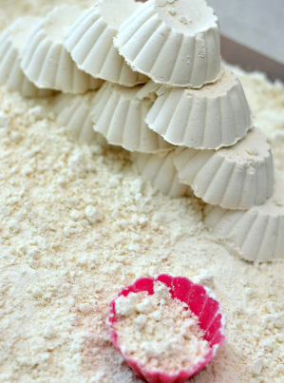

Gross Motor
Some fun gross motor movement ideas to visualise together and play around with
- Move e.g. jump, slide, crawl, crab sideways and backwards

- Lie on your back with your feet pointing to the sky

- Roll like a tortoise out of his shell and stand up quickly and slowly

- Pretend to stretch to push a heavy rock up a hill

- Stretch like a starfish on a beach and jump up like a firework

- Stretch and move lightly like a spider on a web

Here are some links to a few high quality websites with a focus on literacy and mathematics

Literacy:
https://www.phonicsplay.co.uk Phase 1 for Nursery

https://www.bbc.co.uk/cbeebies/shows/alphablocks Alphablocks

Maths:
https://www.bbc.co.uk/cbeebies/shows/numberblocks Numberblocks

Some other useful websites

https://theimaginationtree.com/category/age/ageprescooler/

https://www.topmarks.co.uk/

Search for early years games

http://www.ictgames.co.uk

Fine motor ideas

- Continue with knot tying!
- Hanging up the washing with pegs
- Threading pasta
- Syringes in the bath for squirting water
- Lego!
- Scissors
- Finding the end of the sellotape
- Making a pretend guitar with elastic bands stretched out over a recycling box
- Poking straws in holes
- Weaving wool around random household objects
- Making patterns with natural resources from the garden
- Puzzles
- Ear buds painting
- Stickers
- Dough gym https://www.bing.com/videos/search?q=dough+disco+youtube&view=detail&mid=E340971D8D2B37549A60E340971D8D2B37549A60&FORM=VIRE

Mindfulness
A series of new poses to relax the mind
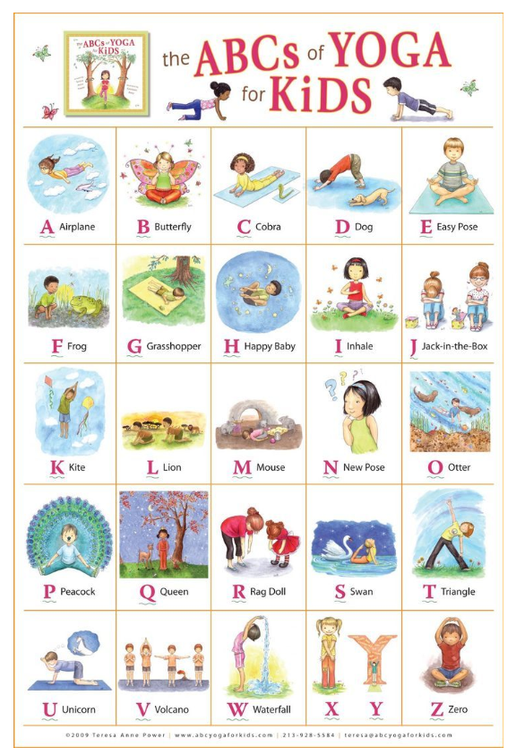

.

We hope this is all of use, please keep us informed on Evidence Me by sending us a picture of what the children were most proud of that week.

Very best wishes,
Mrs Beard and Miss Kaler

